Ok Guys…
I wanted to replace the wires in my original coils and since they are wire core…I figured it would be worth a try. Seems to work well and isn’t that hard to do…
You need a dremel tool with a cutoff blade, a soldering iron, snips, some epoxy glue, masking tape, a sharp knife and a new set of wires.
My local parts house just ordered me a universal 4 cyl. Set. These have the plug boot already in place…at some point I may order a set of the original style plug ends…but I think that’s where most of my trouble was anyway. It would be easy enough to replace the ends whenever.
Here is the finished product…My old sleeves with the plug wire numbers were still good so I put them back on as well.
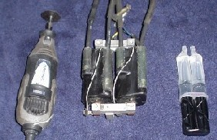

The first one was a bit of an experiment…after I found out how the were made it was easy.
Take the dremel tool and make a cut down each side of the wire…half the diameter of the wire down on each side…it will be a bit V shaped…you can see from these picts about where to stop cutting. When you get deep enough you will see some smoke from the rubber…
Do this carefully…the cutter will cut but also melts the plastic a bit..so you may have to go back and clean the cut a time or two. When you make the END cut across the wire…make sure not to go too deep and cut the center of the wire!!! The end of the original insulation stops about where these cuts are.

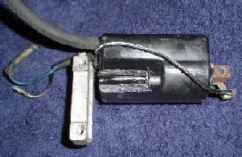

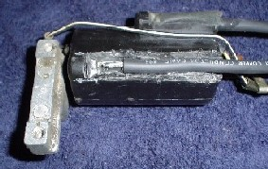

Once you make your cuts…pop the plastic wedge out and your old wire will be exposed…I took the snips and cut the wire off and left about ½ “
Then take a sharp knife and split the insulation and pull it out…this should leave about ½” of bare wire exposed. See above…
Take your soldering iron and “tin” this wire…try not to get it too hot.
Make sure and get “REAL” Solder…the lead free stuff is CRAP! It really doesn’t want to stick to this wire!!! Cut your new wire to the appropriate length…I added a little…the originals were sort of short. Skin about ½’ of the new wire and tin it also…place in the coil and put them side by side…then solder together.
I went ahead and filled the area where the solder joint was with epoxy to make sure it filled properly…let this set up…then clean up the coil with some solvent and get some masking tape.
Make a form shaped like the original coil with the tape and slowly pour in the epoxy to fill the form. Works best if you pour from one side and leave the other open for air to escape…it should fill all the way up and make a nice solid casing…you can see the epoxy through the tape…maybe even better some of the clear boxing tape…
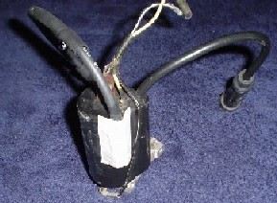

It only took me about an hour or so to do all four wires… and I was very pleasantly surprised at what a difference it made…much nice throttle response down low and smoother Idle.
I’m still running non-resistor plugs…so maybe the boom boom guys will cuss me…
But I don’t really care!!! Next set of plugs I’ll get the resistor type.
I also filled the plug boots with dielectric grease…as the don’t fit really tight on the ITTY BITTY plugs we have!
Hope I made this explanation clear enough…if you have questions…let me know.

